Introduction to ITWS

Quiz 2: April 19, 2018

Place your name on the top of this document in the header

Enter your answers directly into this document (with the exception of #1)

All answers should be in be in Your Own Words, and use proper grammar

Make sure your answers use an alternative font and/or color

Save this document as *yourname*-quiz2.docx

Place all documents including this one in a folder named

ITWSQuiz2-*yourname*-*yourRCSID*

When finished with the quiz, zip your folder and all related files into a file named

ITWSQuiz2-*yourname*-*yourRCSID*.zip

And submit it to LMS

1. Technology (coding): (40 points, 40 minutes)
   1. Given the Quiz2.html, .css, and .js files, make the following modifications; (40 points)

In the HTML;

* Change whatever is necessary to ensure the file(s) adhere to html5 syntax.
* Add your name in the h3 tags
* Change the title of the page to *yourname*-Quiz2
* Add a button at the bottom of the page with an id of “clickMe”
* When the ‘Save’ button is clicked – add the code necessary to POST a request to addText.php

In the JavaScript file:

* Add a function that will execute when the document is ready (You will need the jQuery ready function) and will
  + add a class of ‘blue’ to the <h3> tags
  + Show an alert that the page has loaded
* When the button you added above is clicked – execute the jQuery fadeOut method on the paragraph text with a delay of 1500 ms.

In the CSS;

* Make any text in an element with a class of blue show in blue and in small caps.
* Make “Intro to IT – Quiz 2” and your name centered on the page

Your webpage (with the alert – which I moved for clarity) should look similar to the following;

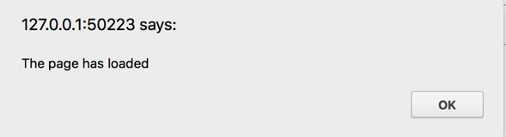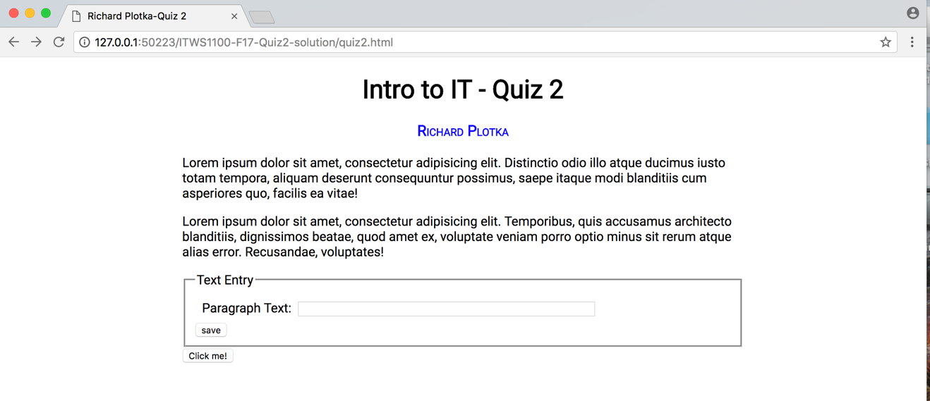

1. Technology (description) (20 points, 10 minutes): Web Development
   1. Explain the difference between IDs and Classes and Pseudoclasses? (2)
   2. Explain the following:

$("ol").filter(":has(li)").css("border", "5px solid blue"); (4)

* 1. Write out the jQuery necessary to select all of the <li> tags with class “error” in a document’s div with a div id of ‘messages’. (4)
  2. Given an index.php file with a form as in the iitajax example from class, explain the process that the webserver goes through to process and send HTML to the browser on a GET request (5), on a POST (5)

1. Git (30 points, 20 minutes)
2. What’s the difference between a “local version control system,” a “centralized version control system,” and a “distributed version control system?” (10 points)
3. What kind of version control system is Git? (3 points)
4. What is SVN, and how does it differ from Git? (3 points)
5. What is a branch, and how is it used? (8 points)
6. What is the “staging area” for git? (6 points)
7. “Predicting Consumer Tastes with Big Data at Gap” Case (10 points, 20 minutes)
   1. List the “three V’s” of big data and provide a definition for each as it relates to big data. (3 points)
   2. Which Gap Inc. brand is best served by the use of big data? Why? (7 points)